NAME:……………………………………………………………………………………………………………….SIGN:…………………….… SCHOOL:………………………………………………………………………………………….……….STREAM………………………….

GOOD CHOICE SECONDARY SCHOOL-KAGALA BUKERERE MUKONO

EXAMINATION TERM 2 2023 BIOLOGY PAPER 1 SENIOR FIVE TIME: 2 HOURS

INSTRUCTIONS
- This paper consists of SIIX structured questions.
- Attempt all questions in this paper.
- Write answers in the spaces provided.
- No extra answer sheet shall be provided for rough work.
- Use a neat hand-writing to present your answers precisely and carefully.

FOR EXAMINER’S USE ONLY
NUMBER | MARKS
1.
2.
3.
4.
5.
TOTAL

1. The figure below shows the rate of photosynthesis against light intensity
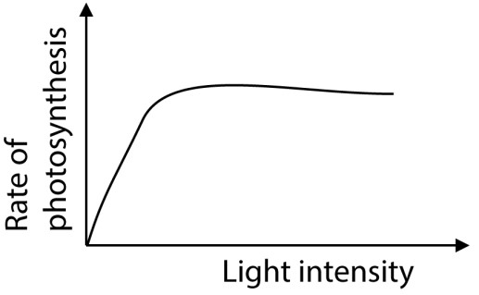

Which one of the following statement is the cause of the flattening of the curve?
- Photosynthetic pigments are saturated
- Too much carbon dioxide is available
- The plant has attained its maximum rate of photosynthesis D There is a factor other than light which is limiting photosynthesis 2. Which of the following does not occur during photorespiration?
- Oxygen is used up
- Wasteful loss of carbon as carbon dioxide
- Carbon dioxide is used up
- Wasteful loss of energy
- The graph below shows the rate of photosynthesis at different light
intensities.
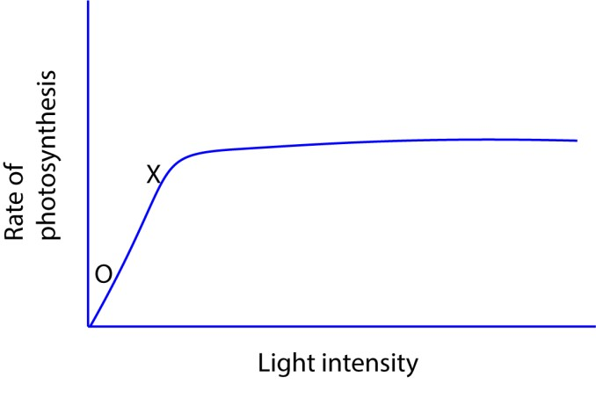
The factor limiting the rate of photosynthesis between O and X is
  - Light intensity B Carbon dioxide. C Temperature
D oxygen

- C3 are less efficient than C4 plants in fixing carbon dioxide at low carbon dioxide and high oxygen partial pressure because
  - C3 plants use more energy
  - In C3 plants, energy is lost
  - RuBP carboxylase is inactivated by high oxygen partial pressure D PEP carboxylase has high affinity for oxygen.
- Photorespiration does not occur in C4 plants because they
  - Use phosphenol pyruvic acid for fixing carbon dioxide
  - Mainly grow at high altitudes
  - Are more abundant in cold region
  - Have succulent leaves which lower the internal temperature
- Photosynthetic bacterial differ from green plants in that
  - They lack chlorophyll
  - Their source of energy is through oxidation of hydrogen sulphide
  - Their source of energy is through oxidation of iron salts
  - Their source of hydrogen is hydrogen sulphide
- Net primary productivity in C4 plants is higher than in C3 plants because
  - C4 plants have a higher turn-over rate
  - Energy accumulates at a higher rate in C4 plants
  - Photophosphorylation occurs in C3 plants
  - The rate of respiration is higher in C3 plants
- Which one of the following curves in the figure below correctly represents plants adapted for low light intensity?

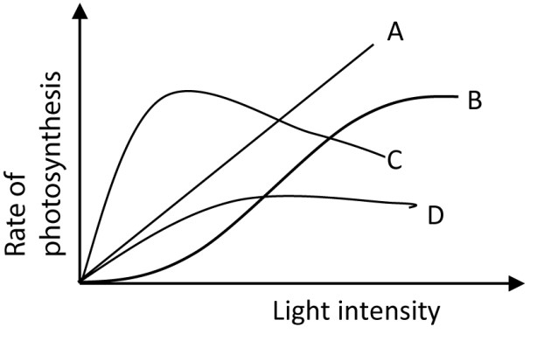

- Which of the following is illustrated in the figure below?
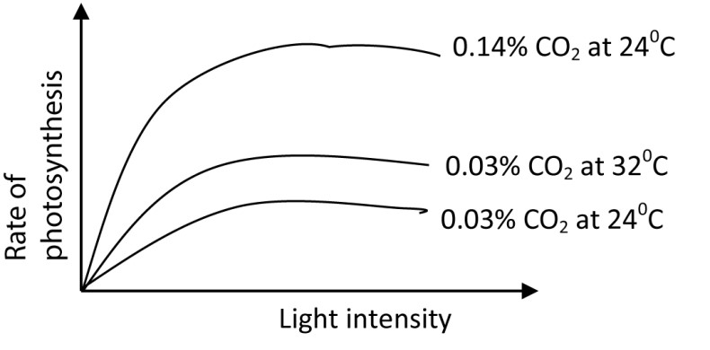

  - With increase in light intensity, the rate of photosynthesis increase until temperature becomes a limiting factor.
  - Rate of photosynthesis increases with an increase in the carbon dioxide
concentration
  - With increase in light intensity, the rate of photosynthesis increases indefinitely
  - Rate of photosynthesis increases with an increase in light intensity until carbon dioxide becomes a limiting factor.
- Which of the following is likely to occur if a photosynthesizing plant was suddenly removed from light?
  - Reduction in PGA
  - Accumulation of PGAL
  - Accumulation of PGA
  - No change in amount of PGAL
11 In which part of the following parts of a chloroplast are water splitting enzymes mostly located?
- Stroma
- Intergrana
- Cytoplasm
- Grana
- Etiolation in plants is usually a response to
  - Insufficient nutrients
  - Low temperature
  - Insufficient light D. Too much water.
- In photosynthesis, the major advantage of the C4 pathway is to
  - Fix carbon dioxide in the Calvin cycle
  - Concentrate carbon dioxide in the cells of leaves
  - Fix carbon dioxide from the atmosphere into the leaves
  - Store carbon dioxide in form of organic acids
14 During the light stage of photosynthesis, water is important in that it
- Gives of oxygen
- Provides hydrogen that reduce NAD
- Reduces carbon dioxide to carbohydrates
- Provides electrons

15. Figure below shows the relationship between temperature and rate of photosynthesis in two species A and B.
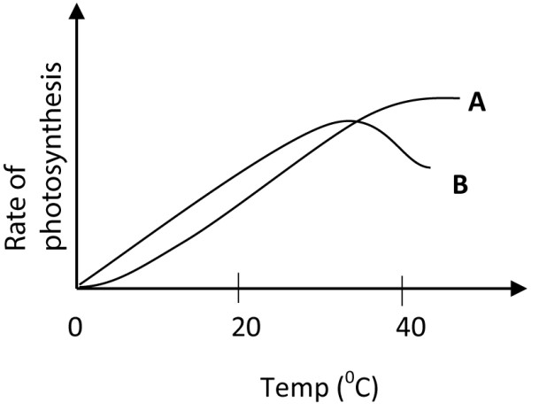
Which one of the following is correct conclusion from the results?
- B is a shade plant while A is a sun plant
- A has a lower compensation point than B
- A has a higher optimum temperature for photosynthesis than B D Photorespiration does not occur in A but occurs in B
16 Which of the minerals nutrient are constituents of chlorophyll?
- Potassium and sulphur
- Nitrogen and magnesium
- Calcium and phosphorus
- Zinc and copper
- Photosynthetic bacteria differ from plants in their nutrition in that the bacteria
  - Derive their energy from oxidation of ammonia
  - Obtain hydrogen for reduction of carbon dioxide from hydrogen sulphide
  - Possess chlorophyll b to trap sunlight
  - Oxidise hydrogen sulphide to obtain energy
- Which one of the following is the role of reduced NADP in the dark stage of photosynthesis?
  - Combines with carbon dioxide
  - Provide energy
  - Provides hydrogen
  - Acts as an electron acceptor
- Which one of the following colours of light are most effective in photosynthesis?
  - Green and red
  - Blue and red
  - Blue and yellow
  - Blue and green

- Which wavelength from light spectrum is mostly absorbed by green plants?
  - Red
  - Green
  - Blue
  - Yellow
- Where in the cell dos the reduction of carbon dioxide occur during photosynthesis?
  - Lamella
  - Stroma
  - Quatasome
  - Grana membrane
- During what stage of the dark reaction is NADPH₂ used? Conversion of
  - Ribulose diphosphate to phosphoglyceric acid
  - Phosphoglyceraldehyde to hexose sugar
  - Hexose sugar to starch
  - Phosphoglyceric acid to Phosphoglyceraldehyde
- The figure blow illustrates the phenomenon of limiting factors. What, in this case, is the limiting factor for photosynthesis?
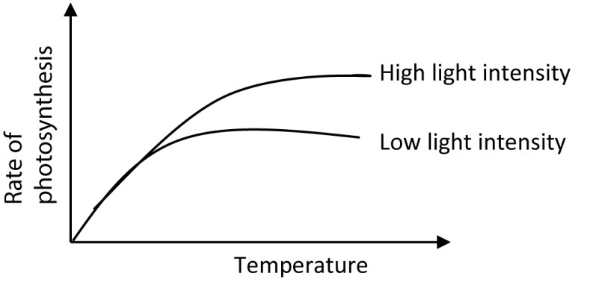
  - Chlorophyll content
  - Temperature
  - Carbon dioxide
  - light
- Which of the following occurs during the light dependent stage of photosynthesis?
  - Formation of ADP
  - Formation of NADPH₂
  - Formation PGAL
  - Production of NAGP⁺

- Which of the following pairs of reactants is not required for the lightindependent reaction of photosynthesis?
  - NADPH and ATP
  - ATP and carotenoid
  - RuBP and free oxygen
  - Carbon dioxide and enzymes

26. Starch, glycogen and cellulose are all composed of
- α-glucose
- β-glucose
- monosaccharides
- polysaccharides
27. Some amino acids are known as essential because they are
- more important in the body metabolism than other
- not made by the body
- contained in first class proteins
- required in larger amounts than others.
28. Which of the following sugars is not reducing?
- Maltose
- Fructose
- Galactose
- Sucrose
29Among the following compounds, one cannot be hydrolyzed is
  - Glycogen
  - Galactose
  - Lactose
  - Maltose
30.Which one of the following is the correct formula of a polysaccharide?
  - (C6H10O5)n B. (CH₂O)_{n}
  - (C6H12O6)n
  - C12H22O11)n
31.Which one of the following statements is true of essential fatty acids? They
  - They are the most required lipids in the body
  - Are required in the body in large quantities
  - Cannot be synthesized in the body
  - Are most abundant in animal tissues
32.Which one of the following properties of water facilitates its efficient transportation of glucose?
  - Forms hydrogen bonds with other molecules
  - Has high surface tension
  - Has low freezing points
  - Has high boiling point

32 An enzyme which catalyze the conversion of dipeptide into separate amino acid is example of
  - Dehydrogenase
  - Hydrolase
  - Transferase
  - Oxidase
33.An enzymatic reaction of the type
ATP + hexose ADP+ hexose-6-phosphate is an example of
  - A hydrolysis
  - An isomerase
  - Transfer
  - A synthesis
34.When a piece of liver is dropped into containing H₂O₂, there is vigorous reaction. this is due to enzyme
  - Catalyze
  - Amylase
  - Trypsin
  - Carbonic anhydrase

35.In the lock and key hypothesis for the mechanism of enzyme the mechanism of enzyme action, how does inhibitor substance stop enzyme action? By
  - Raising activation energy
  - Distorting substrate molecule
  - Destroying coenzyme
  - Occupying active sites on substrate and enzyme
36.When the extent of inhibition in an enzyme controlled reaction depends entirely on the concentration of the inhibitor, it indicates that the inhibition is
  - Competitive
  - Reversible
  - Non-competitive
  - Irreversible.

37.Which one of the following is not true about the lock and key theory in enzyme-catalyzed reaction?
  - A small change in the active site alter the enzyme
  - The substrate and active site are complementary
  - Enzyme catalyzed action go through the enzyme-substrate complex stage
  - A molecule which fits in the active site is a substrate
38.Which one of the following does not have an effect on a non-competitive inhibition?
  - Temperature change
  - pH change
  - enzyme concentration
  - substrate concentration
39.Which one of the following describes the turnover number of an enzyme?
  - Number of molecules affected by the enzyme
  - Number of substrate molecules turned into its product per minute
  - Number of product molecules formed
  - Number of substrate molecules catalyzed per minute
40.Which of the following is true about non-competitive inhibition of enzyme catalyzed reaction?
  - The degree of inhibition decreases with increase in substrate concentration
  - The inhibitor has a similar structure and chemical composition with the substrate
  - The degree of inhibition is independent of the substrate concentration D. The shape of the enzyme is not affected by the inhibitor

41.Figure 7 show the concentration -3 phosphate (GP) and ribulose bisphosphate (RuBP) during an investigation in which a sample of chlorella was allowed to photosynthesis at very low and very high carbon dioxide levels.
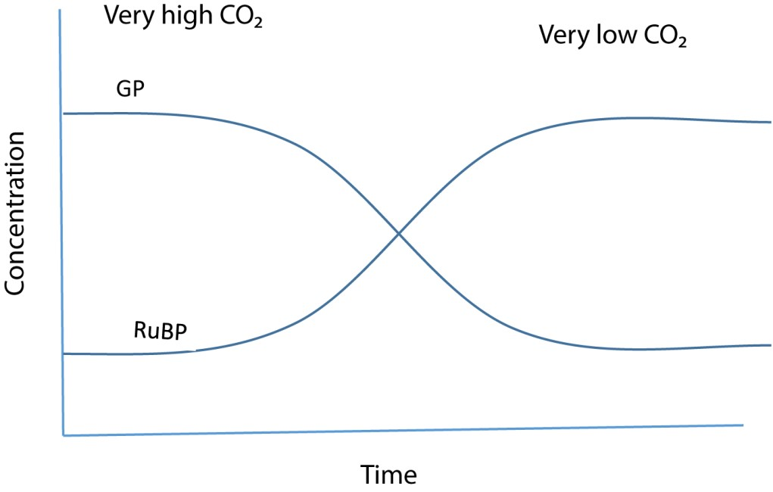
Explain the change in concentration of RuBP at
High carbon dioxide levels

Very low carbon dioxide levels

Suggest why the concentration of GP falls when the levels of carbon dioxide is reduced

Name two factors which must have been kept constant in the investigation (d) Give four
difference between cyclic and noncyclic photophosphorylation

42. What is chemosynthesis? (1mark)

Outline three ways in which photosynthesis in purple sulphur bacteria differs from that of higher plants (3marks)

Explain why it is possible for photosynthetic and chemosynthetic bacteria to co-exist in an oxygen free environment? (3marks)

State the importance of chemosynthetic bacteria in nature. (3marks)

43.The figure below shows light saturation curves of photosynthesis for plants of the same species growing under different light intensities.



O
Region Y
CO
2

uptake

µmolh
-
1
dm
-
2
Light intensity

Light plants
shade plants
P

Compare the effect of intensity on the carbon dioxide uptake in the two types of plants.
(4marks)

Describe the state of the light plants at point P. (2marks)

Explain what happens to the plant biomass in region Y. (2marks)

State an environmental factor that affects the shape of the graph other than carbon dioxide (2marks)

44.Fat and glycogen are energy storage compounds in animals

Compare the suitability of the two substances as storage compounds (4marks)

State advantage of storing fat over glycogen (3marks)

Why is glycogen more suitable energy compound in muscle than fat? (3marks)

45.Using the structural formula
H
HOH
HOH
C
C
C
HOH
H
For glycerol, and molecular formula CH₃(CH₂)_{n}COOH for a fatty acid show the formation of
triglyceride from fatty acids and glycerol. (2marks)

What properties do lipids possess as storage food substances? (2marks)
Outline the structural and physiological functions of lipids in living organisms.
Structural (3marks)

Physiological (2marks)

46.. Explain the following
Competitive inhibition

In what way do enzymes differ from catalyst?

Briefly describe the lock and key hypothesis of enzyme action

END
“GOOD LUCK”

